

Assignment – 1

• Install Power BI Desktop and share the final screenshot of the report view page which appears when power desktop starts.
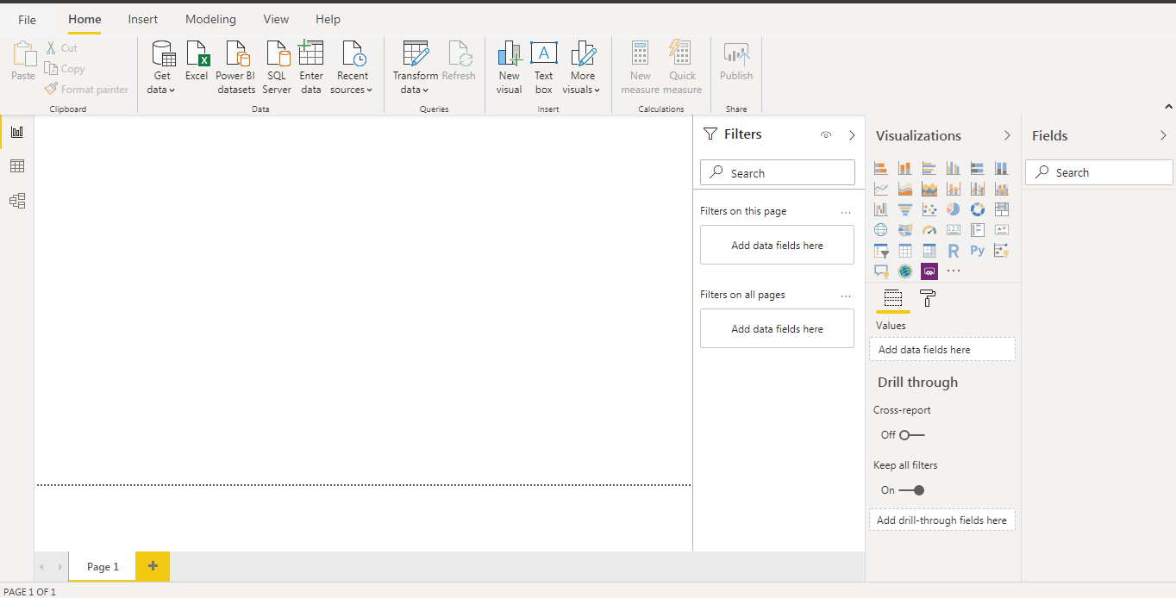

• Prepare a document and with the following screenshot
− Report View
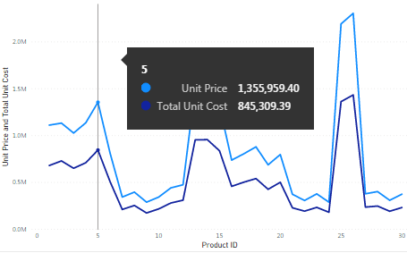
− Data View
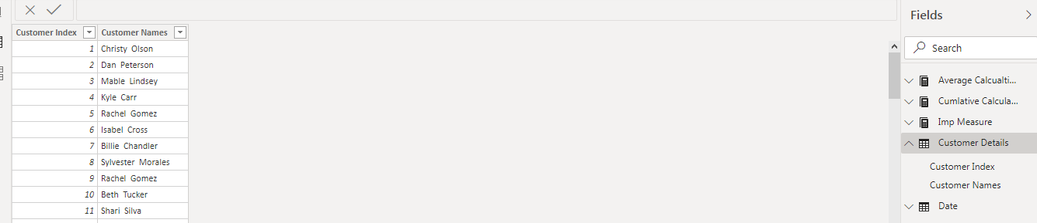
− Model View
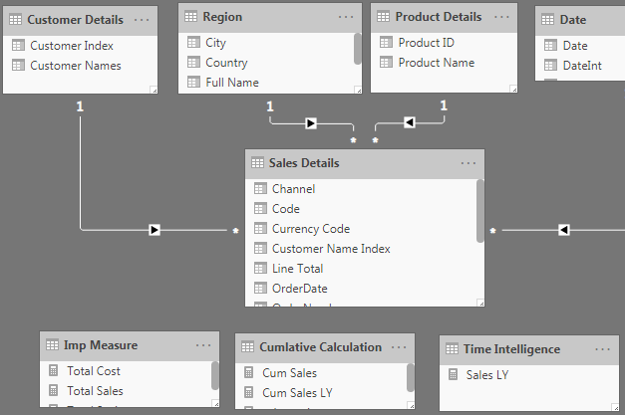
− Power Query Editor
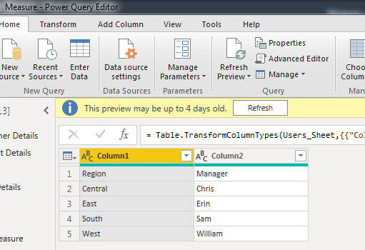
− Advance Editor
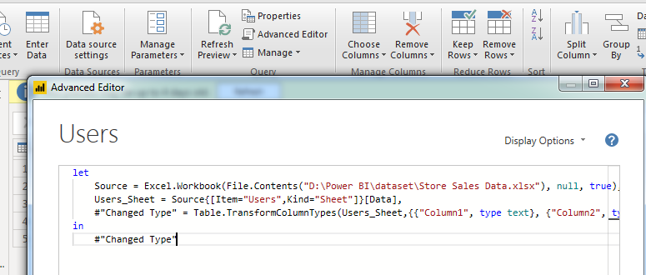

• Prepare a document with details of the following along with their price

− Power BI Desktop
Free Download. It includes data cleaning and preparation, custom visualizations and the ability to publish to the Power BI service.
− Power BI Pro
$9.99/user/month. It includes data cleaning and preparation, custom visualizations and the ability to publish to the Power BI service. It includes data collaboration, data governance, building dashboards with a 360-degree real-time view and the ability to publish reports anywhere.
− Power BI Premium
$4,995 a month per dedicated cloud compute and storage resource

